Process Documentation
Purposes:
- For tracing back errors arise after changing code.
- To document the concepts for reference.
- To explain about the problems encountered and the methods used to solve the problems.

Implementation:
- Temporary scoreboard
- Implemented temporary scoreboard to observe the players’ movements.
- Players kept resetting back to beginning. Fixed: implemented accumulating formula to simulate players’ movements to further spaces.
- Snakes and Ladders functions
- Implemented four arrays: snakes_start[n], snakes_end[n], ladders_start[n], ladders_end[n]. To get the same indices [i] for start and end, either snakes or ladders. Problems: More error prone as mix up between starts and ends likely happen; inefficient.
- Changed to two arrays: snakes[n], ladders[n]. index[i] is start, index[i+1] is end, either snakes or ladders. Problems: inefficient and error prone; hard to read data mixing in starts and ends in an array.
- Changed to one struct SNAKELADDER: int type as identifier it’s a snake or a ladder. Problems: inefficient to search through for a data as additional checking step required.
- Changed to two structs SNAKE, LADDER: int start and int end to store start and end spaces. Problems: had to search for matching space number (for start space in SNAKE/LADDER) to get the end space each time encountering a snake/ladder.
- Changed to include snakes and ladders locations in struct BOARD: with just int move for storing the end space of that snake/ladder, as reaching the current space with snake/ladder in it indicated that the start space.
- Randomize snakes and ladders placements
- Implemented generate_snakes_ladders() function. Declared exist_snakes_ladders array for storing return values from generate_snakes_ladders(), for checking purpose to ensure no multiple snakes and/or ladders exist in the same space. Problems: inefficient, as each time storing the return value, linear search through exist_snakes_ladders had to be done to ensure no conflict values.
- Changed to storing return values from generate_snakes_ladders() directly into struct BOARD, and check for existing snakes/ladders placements by checking if current space in board has any snake/ladder value (placement).
- Board rendering
- Code design ideas:
- Render board on the go (board rows * cols). Problems: have to constantly check with additional functions isPlayerThere(), isSnake(), isLadder(), etc. for every move.
- Using struct[rows][cols]. Can directly check struct[i][j] for players array, isSnakeLadder, etc., skipping unnecessary functions calls and searches.

- Look and feel:
- Completely textual look.
- ASCII art look idea for version 2.
Testing Process:
- Implemented get number of players function (2-4 players); temporary scoreboard to keep track of players’ current spaces; generate dice (randomize from 1-6).
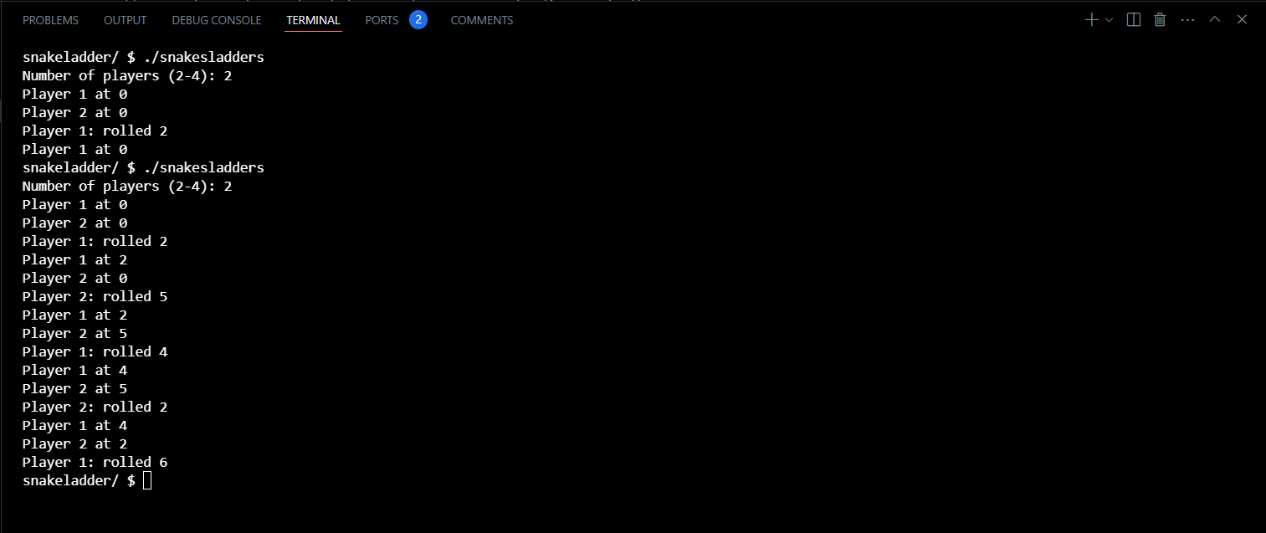
- Inefficient: only one player rolls the dice each round; players’ movements not recorded properly (not moving forward). Fixed: implemented an inner loop, all players roll the dice before moving next round; accumulating formula to record players’ rolls to simulate movements; implemented rounds function to abstract away rolling and accumulating functions.
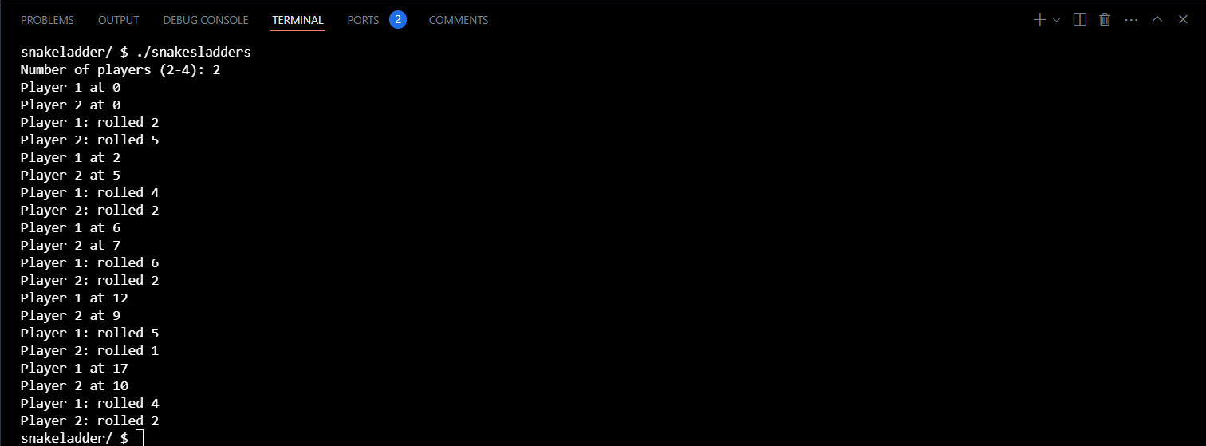
- No encounter snakes/ladders functions; no check for winner function.
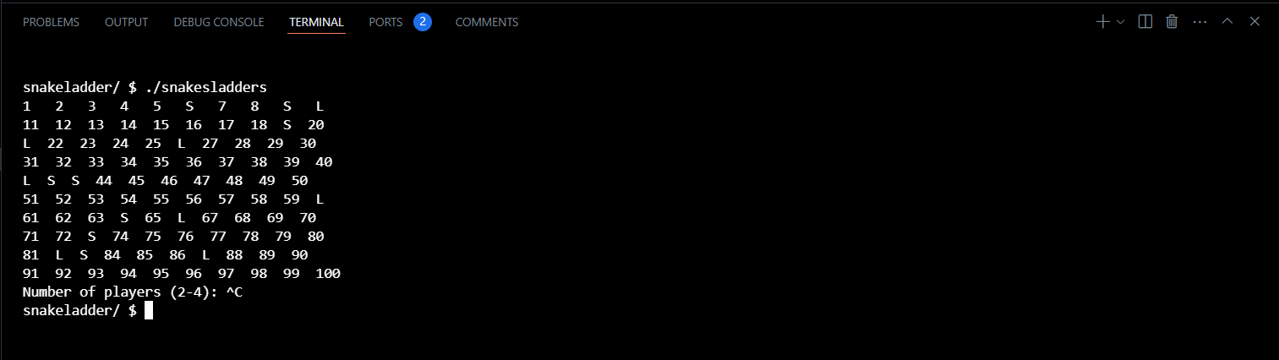
- Implemented and tested board generating function, snakes and ladders placements function with randomized locations each time re-running the program; improved retrieving snakes and ladders end points to be able to directly index into.
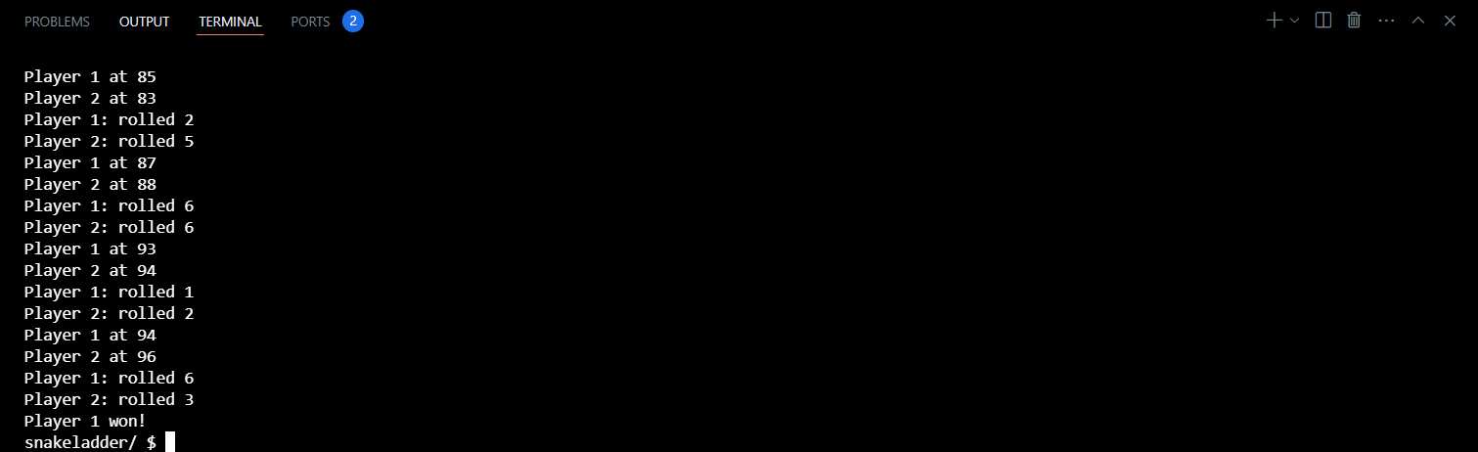
- Implemented function to check for winner and stop the game whenever a player reaches 100th space.
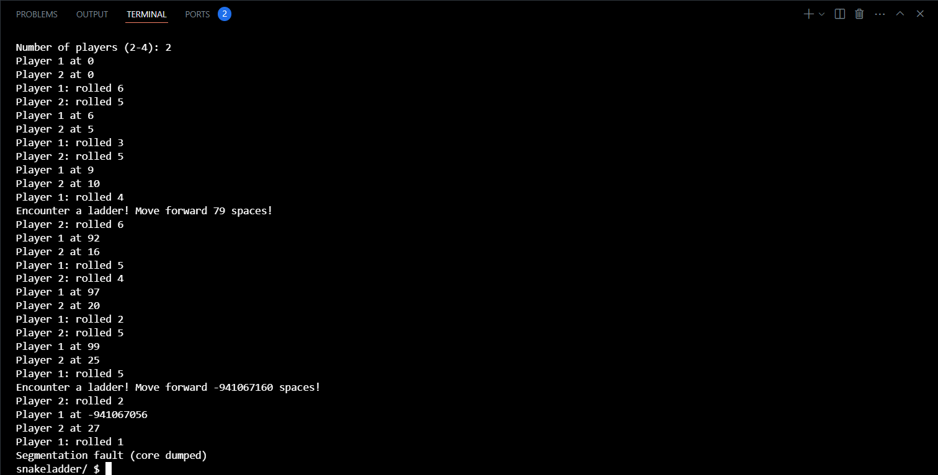
- Implemented encounter snake/ladder function. Segmentation fault occurred as validation when reaching over 100th space not implemented, and function calls indexed into invalid array indices (out of range).
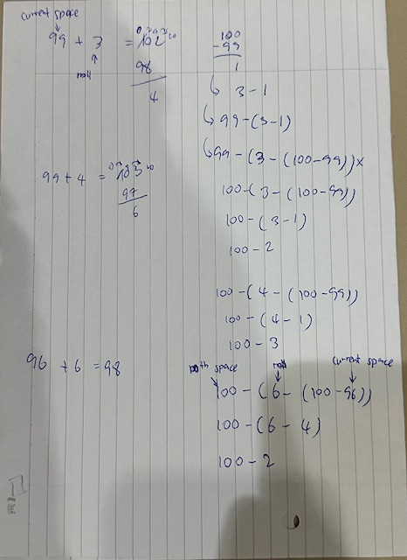
- Fixed segmentation fault error by validating if current space + roll dice > 100, and apply the formula above for the value for current space.
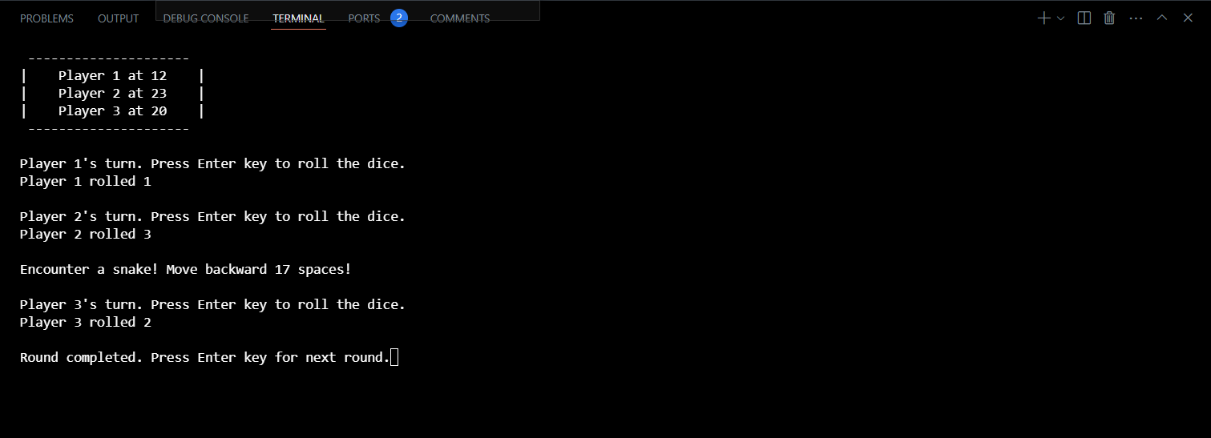
- Version 1 completed. Slight improvement: cleaned up unnecessary variables; added manual intervention; cleaned up input stream that caused slight bug when added manual intervention (cleared scanf input stream until \n); added lines and spaces for aesthetic purposes.
Areas of Improvement (Urgent to least important):
- Optimization - Potential board rendering.
- Feature - Visualize board (to be implemented in version 2).
- Feature - Visualize snakes and ladders (to be implemented in version 2).
- Feature - Determine players’ first turns.
- Feature - Game guides.
- Feature - Challenge levels (normal, hard): next player reaching same space with existing players will kick existing players back to square one; more snakes, less ladders.

